Housing Development Corporation of Rock Hill Board Meeting

Thursday, April 17, 2025

A Board Meeting was held Thursday, April 17, at 8:30 a.m. at Operations Center, Room 136.

**Members present**: David LeGrande, Sandra Oborokumo, Will Jordan, Mary Reid, Perry Sutton, Naomi Carpenter, Phyllis Fickling, Walter Hardin, Warren Baxter

**Members absent**: Anne Lambert, Sharon Hines, Brent Faulkenberry, Tom Roper

**Staff present**: Corinne Sferrazza, Beverly Buchanan, Danielle Sanders, David Martin, Sarah Bechtold, Leslie Andino

**Guest:** Atalie Zimmerman, Alexandria Newberry, Larry Winch

Call to Order: Walter Hardin called the meeting to order at 8:33 a.m. and thanked everyone for attending.

Minutes of the March 13, meeting was reviewed. Walter Hardin asked for a motion that the minutes be approved as presented. Will Jordan made a motion to approve. David LeGrande made the second. Unanimous approval.

**Staff Reports**

**A. Financials**

Financial information was shared with Board members. Financial information can be e-mailed, or a hard copy can be mailed to Board Members if requested. Account balance information for the South State Community Checking Account (Sunset Park Houses) is $59,725.65. The Wells Fargo Account (HDC rentals) balance is $37,414.42. The TD Bank (Cottages) balance is $60,065.08. The NSP Rental Properties balance is $5,900.81. The TD General account is the main account with the most activity that includes utility and rental assistance transactions, deposits for assistance and proceeds for home sales, the balance is $23,663.02. Total Unrestricted Funding as of 3.31.2025: $233.404.25.

|  |  |  |
| --- | --- | --- |
| **Finances** | |  |
|  | **Last Months** | **This Month** |
| **Total Funds as of 3.31.2025** | **$509,820.41** | **$496,414.53** |
| Restricted for Rental Properties | $161,114.79 | $163,105.96 |
| Restricted Grant Funds | $13,396.45 | $12,144.90 |
| Restricted/Held Funds for Projects | $77,759.42 | $87,759.42 |
| **Total unrestricted funds as of 3.31.2025** | **$257.549.75** | **$233,404.25** |

**BUY**

David Martin reported:

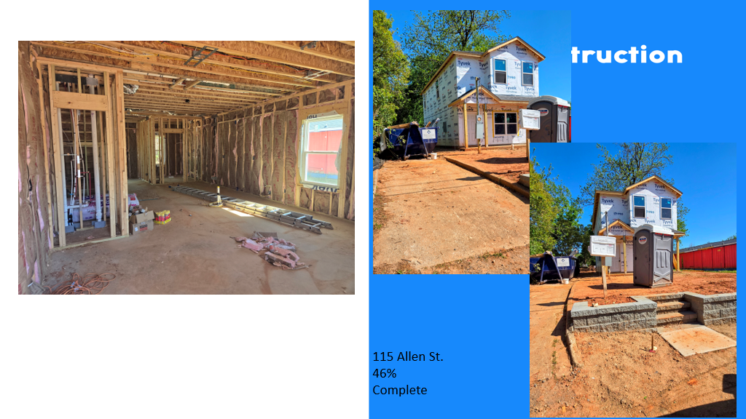

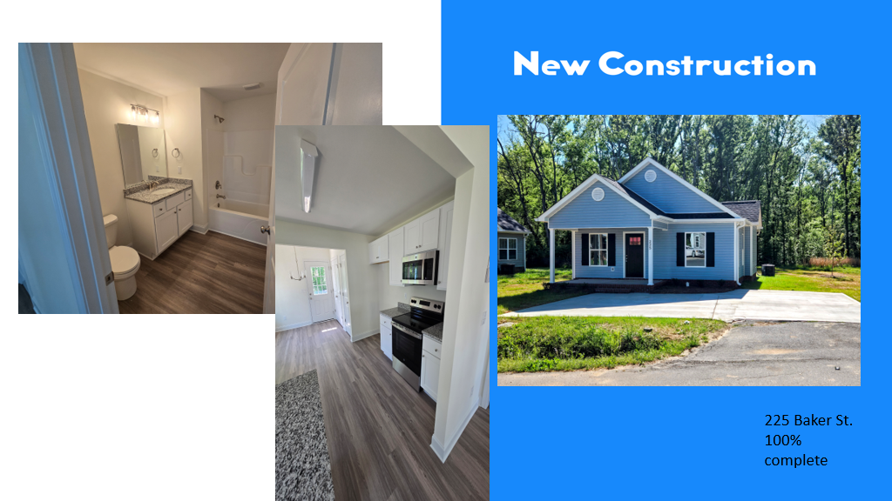

New Construction - For sale properties

* **115 Allen St. – 46% complete**
* **225 Baker St. – 100% complete – CO issued – Starting the process to sell**

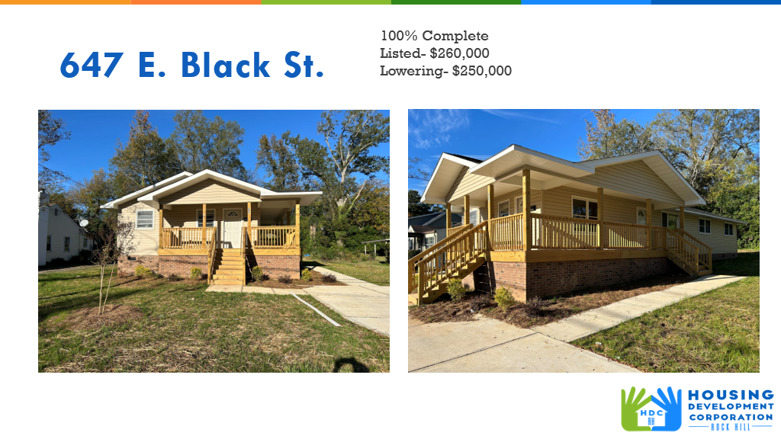 **647 E. Black Street**

* For sale property
* Lowered price to $250,000
* Offer has been made

**First Time Homebuyers** –

Corinne advised for the month of March and advised that an offer has been accepted by a former intern for the Community Development Specialist, and her start date is May 5.

Client Intake: 21

Students who received certificates: 3

Closings with assistance: 0

Counseling sessions: 0

# enrolled in next in-person class - 3

Next class: TBD

CDBG 24/25 Funding - $35,070

CDBG 25/26 - $45,000 (proposed)

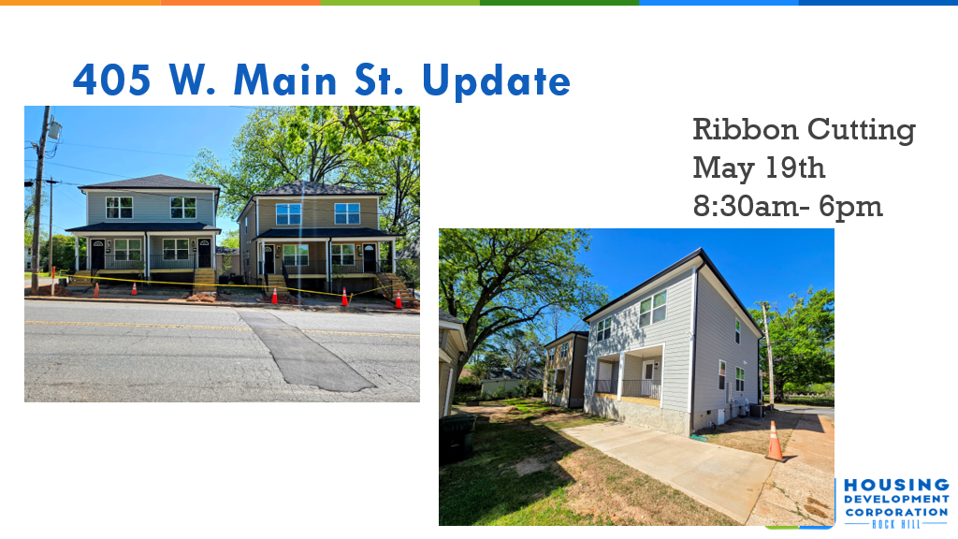  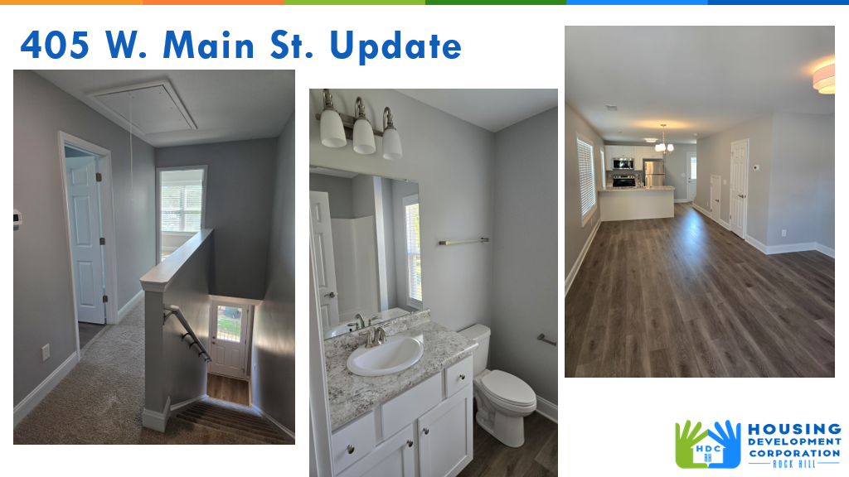

David reported on 405 W. Main Property:

Ribbon Cutting is scheduled for May 19, 2025.

* CO issued
* Two duplexes with four units – 2-bedroom, 1.5 bathroom
* Permanent supportive housing for individuals experiencing homelessness– rapid rehousing – Grant funding

**FIX**

Corinne Sferrazza introduced HDC’s new Rehab Coordinator, Leslie Andino. Corinne stated that HDC is fortunate to have her. Leslie worked in Neighborhood Services as a Code Enforcer.

Leslie Andino introduced herself to the board and advised that she is privileged to be a part of HDC’s mission.

Leslie Andino reported on FIX

**Rehab Projects- CDBG – Southside Home Improvement Program (SHIP)**

|  |  |
| --- | --- |
| **Stage** | **Amount of Units** |
| **0** | **3** |
| **Bidding** | **0** |
| **In Construction** | **3** |
| **Completed** | **2** |

**Rehab Projects- – CDBG – Owner Occupied Rehab**

|  |  |
| --- | --- |
| **Stage** | **Amount of Units** |
| **Pre-Work** | **0** |
| **Bidding** | **4** |
| **In Construction** | **1 (bid awarded)** |
| **Completed** | **3** |

**Rehab Projects- – CDBG – Summer Missions**

|  |  |
| --- | --- |
| **Total Projects to be completed** | **12** |

**Rehab Projects – HTF- Critical Home Repair & Home Repair**

|  |  |
| --- | --- |
| **Stage** | **Amount of Units** |
| **Pre-Work** | **2** |
| **Bidding** | **0** |
| **In Construction** | **0** |
| **Completed** | **0** |

**Rehab Projects**

CDBG 23/24 CDBG 24/25

OOR - $4,236.30 OOR - $100,000

Volunteer Projects-$38,376.73

SHIP - $46,320

Waitlist – 16 (2 completed)

**KEEP**

**Homeless Prevention Assistance**

Rent Assistance for Hotel/Motel Stays Starting balance: $37,000

Total funding spent - $12,373.68

Remaining balance - $10,405.95 (72% expended)

# of households assisted – 5 (11 Total)

# of individuals assisted – 15 (33 Total)

Danielle Sanders advised on the CDBG funding and details on applicants that have received financial assistance to help them transition from a hotel or motel to permanent housing. Individuals can apply on the HDC website: [www.hdcrh.org](http://www.hdcrh.org). Funding is expected to move quickly

**Rapid Rehousing Update (CoC and ESG)**

Funding Available: $79,820

Funding Remaining: $14,926.20 (ESG)

$32,479.17 (CoC since last draw)

RRH Counseling sessions: 0

(moved family and individual in)

**Individual Development Account Program (IDA)**

Number of Accounts opened: wrapping up pilot

Funding remaining: $16,600

**Housing Navigation**

Number of New Landlord Connections – 0

Households Moved-In – 0

Total Persons Served – 22 adults/18 children

RRH Rental applications submitted - 0

Sarah Bechtold reported on Rapid Rehousing, IDA and Housing Navigation

**FURNITURE NEEDED**

* **CACH: CACH Housing Assistance Network**

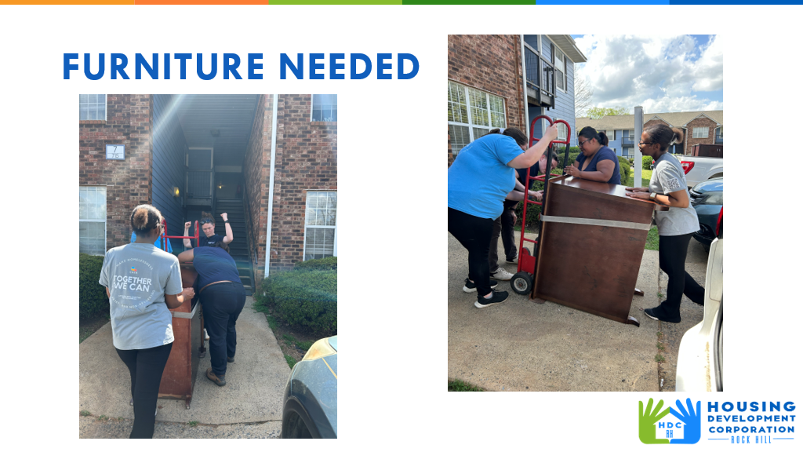

**Rental Properties**

Danielle advised on rental properties for the month of March

Danielle also gave highlights on the individual that moved in 509 Bynum property.

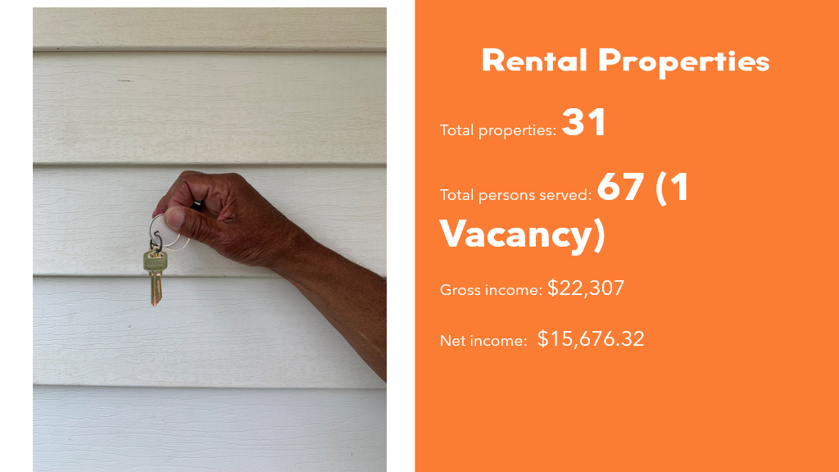

**Grants Update**

* **Received**
  + - Continuum of Care (CoC) - $43,383 - Rapid Rehousing
    - Disaster Assistance Program (DAP) – SC Housing
      * 15% will be Delivery Fee – total of $441,003 for projects $77,824.05 in Delivery fee
    - Springs Close Foundation - $10,000 furniture for 405 W. Main bedrooms
* **Applied**
  + - TD Bank Charitable Foundation - $25,000 IDA program funding

**Old Business**

Corinne advised on Rebuild Southside Phase II. Houses were identified by Code Enforcement and Habitat.

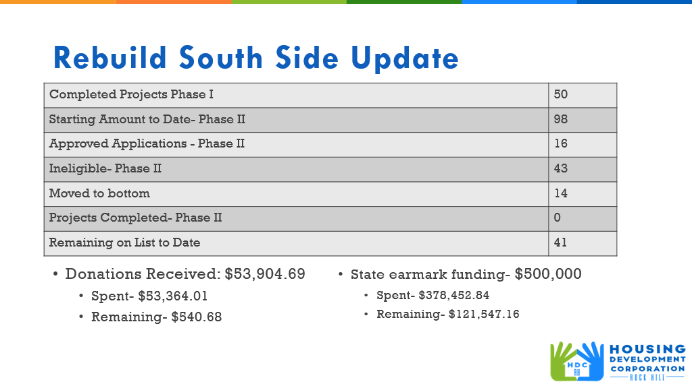

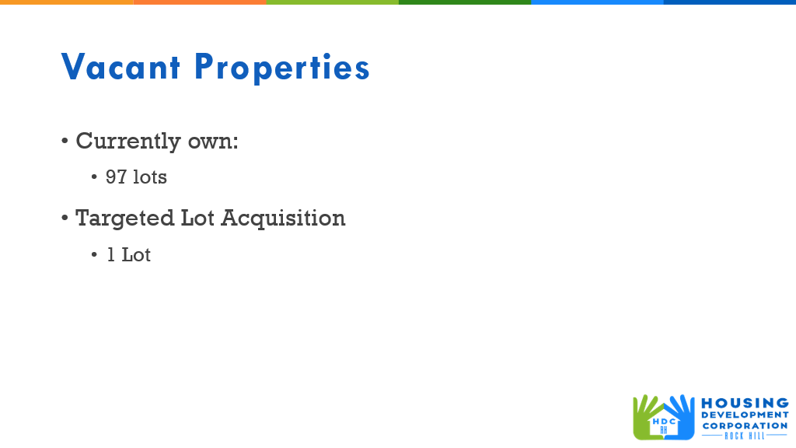

**New Business**

Corinne advised that Rachel, the consultant could not be at the meeting today to answer questions regarding making HDC more sustainable. The consensus is to come up with leveraging what HDC currently has to create more funding in HDC.

Phyllis Fickling commented that we should look further than just the grants we’re getting in order to make the program sustainable, discussion followed.

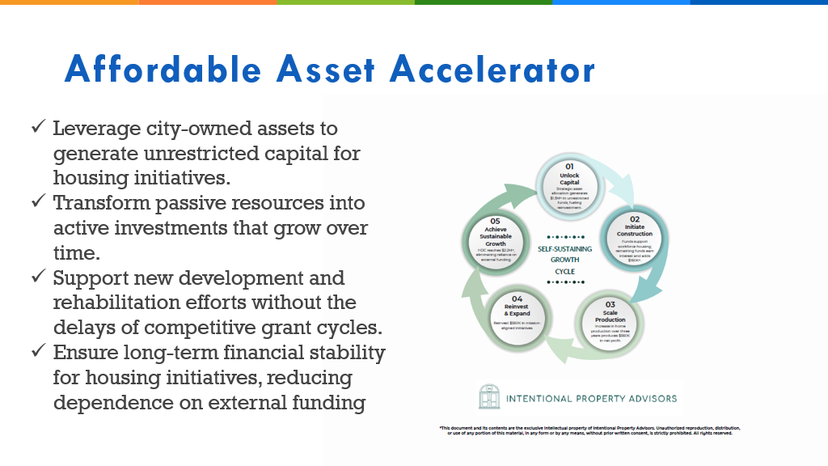

Larry Winch with the Racial Reconciliation Committee advised that he came today with the concern for low-income housing, specifically tiny homes. He stated that he wants to know what is being done to make places zoned properly so these type houses can be built. Considerable discussion followed.

**Adjourn**

With no further business, the meeting ended at 9:44 a.m.

Next Meetings: HDCRH Board Meeting, Thursday, May 8, 8:30am – **Operations Center, Room 136**

Submitted by: **Beverly Buchanan**  
 Beverly Buchanan, Secretary  
 Date: April 24, 2025

______________________  
Chairman/Vice Chairman  
Date: